**COLD STORAGE MONITORING**

**G.Sailaja 1,Ponnala Naveen2, Anand Charan3,** **Surasani Manideep4,**

**Inala Venkata Hari Paniindra5**

1-4Department Of Internet Of Things, Malla reddy University, Hyderabad, Telangana, India.

5Assistant Professor, Department of Internet of Things, Malla reddy University, Hyderabad, Telangana, India.

**g_sailaja@mallareddyuniversity.ac.in 1,**[**2111cs050090@mallareddyuniversity.ac.in**](mailto:2111cs050090@mallareddyuniversity.ac.in)**2**

[**2111cs040072@mallareddyuniversity.ac.in3**](mailto:2111cs040072@mallareddyuniversity.ac.in3)**,**[**2111cs050117@mallareddyuniversity.ac.in4**](mailto:2111cs050117@mallareddyuniversity.ac.in4)**, 2111cs050106@mallareddyuniversity.ac.in5**

**ABSTRACT**

**Iot technology has enabled the development of useful application to improve the quality of life. We can also the need to develop other application to make an effective use of the devices and the internet connectivity. Our project trys to solve the problems occuring due to lack of monitoring of our goods. In this regard we have taken the first to solve the problem by proposing a project which can Monitior the temperature of goods present in an container and notify the person in-charge according to the constraints he/she have provided .For this project we will be using ESP32 as the processing unit due to wireless wifi connectivity and upload HTML code to monitor temperature and daily usage of our model through the local network connected to the device.**

**Keywords**: Monitor ,ESP32,Alerts,Cold Storage,NodeMCU,DHT11 Sensor

**I. INTRODUCTION**

The Internet of Things (IoT) is a new, but at the same time is an old term. It is already mentioned by Kevin Ashton in 1999. Sincethen the use of this term has blossomed andmajor companies have predicted anincrease in IoT. One prediction is that the number of connected things in the world will have thirtyfold increases between 2009and 2020, thus by 2020 there will be 26 billion components are connected in IoT devices.

The components we are using in this equipment are ESP32 wroom dev kit, temperature sensor bsm280,led’s,Bread board are the things which are used to build an working prototype of the device.

The main justification of ESP32 module is easy to usage in connecting to wireless networks and being capable of connecting to commonly available communication devices like the Wifi and Bluetooth which are proven to be useful and do not need an external connections or modules to establish an connection. The bsm280 is an temperature and humidity sensor capable of calculating humidity and temperature and can also calculate altitude if required directly to.

**II. METHODOLOGY**

We connect our esp32 module with temperature sensor(BSM280 ) and use webserver connection to integrate these two by using Software libraries like JSON, The web development is done to display to the temperature readings based on the constraints if the temperature is under the specified constraints the green led is seen glowing. When the temperature increase above the limit a led will glow notify the in-charge about temperature .

**III. MODULE DESCRIPTION**

Now-a-days the control of temperature has become an important task in many operations. The method that we used to build, can be operated manually and automatically. So, the method we used to control the temperature is to initialize the serial monitor, temperature sensor test, and Webserver connection. Then we measure the temperature threshold value or the set pointvalue i.e., we will be using the setpoint to compare the current temperature that to be measured and it switch on the led and email notification according to the given condition

### System Architecture & Components

The system architecture and components of IoT based Temperature Monitoring System Using NodeMCU & Blynk App. The system consists of four main components: the NodeMCU 32s module, DHT11 Sensor, 5V 2-Channel Relay Module, DS18B20 Temperature Sensor as shown in the figure 2.

### ESP32 Wroom dev kit

The ESP32-WROOM module features a powerful 32-bit dual-core microcontroller running at up to 240 MHz. It's based on the Tensilica Xtensa LX6 architecture, which is highly efficient and offers great performance. One of the key features of the ESP32 is its built-in Wi-Fi and Bluetooth connectivity, which makes it ideal for IoT projects requiring wireless communication. It supports various Wi-Fi modes (station, access point, or both simultaneously) and Bluetooth Classic and BLE. The ESP32-WROOM module includes a wide range of peripheral interfaces, such as SPI, I2C, UART, ADC, DAC, and more, making it versatile and suitable for a variety of projects

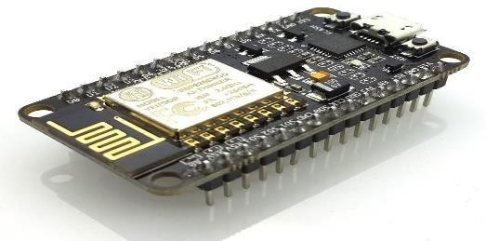

### Fig. 1. NodeMCU ESP32

#### DHT 11 Temperature and Humidity sensor

The **DHT11**is a commonly used **Temperature and humidity sensor.** The sensor comes with a dedicated NTC to measure temperature and an 8-bit microcontroller to output the values of temperature and humidity as serial data. The sensor is also factory calibrated and hence easy to interface with other microcontrollers.

The sensor can measure temperature from 0°C to 50°C and humidity from 20% to 90% with an accuracy of ±1°C and ±1%. So if you are looking to measure in this range then this sensor might be the right choice for user.

### 

### Fig. 2 DHT11 Temperature and Humidity Sensor

### OLED

Organic Light Emitting Diode (OLED) technology is a display technology that uses organic compounds to emit light when an electric current is applied. Unlike traditional LCDs that require a backlight, OLEDs are self-emissive, meaning each pixel generates its own light. This characteristic allows for deeper blacks and higher contrast ratios, as individual pixels can be turned off completely

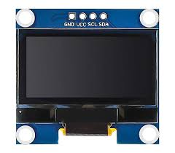

**Fig. 3. OLED display**

**V. RESULTS & DISCUSSION**

**Process**

**1.Setting up Wi-fi modules:-**

Connect to set up the wifi using credentials and the email credentials and if authentication is done and is sent.

**2.Set the threshold values:-**

By default 25 degrees is set as threshold values you can do so. Thevalues are compared with readings and are updated when constraints are checked.

**3.Notification:-**

The user is notified if the temperature is not in the constraint of temperature he/she has set using the objects through the notification of LED. And email

**Results:**

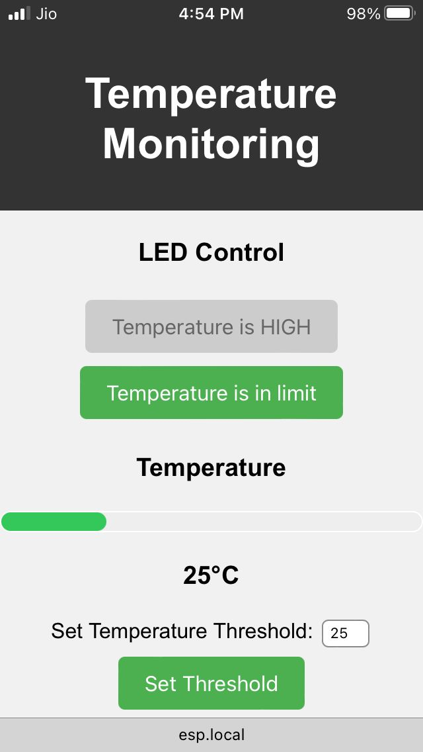

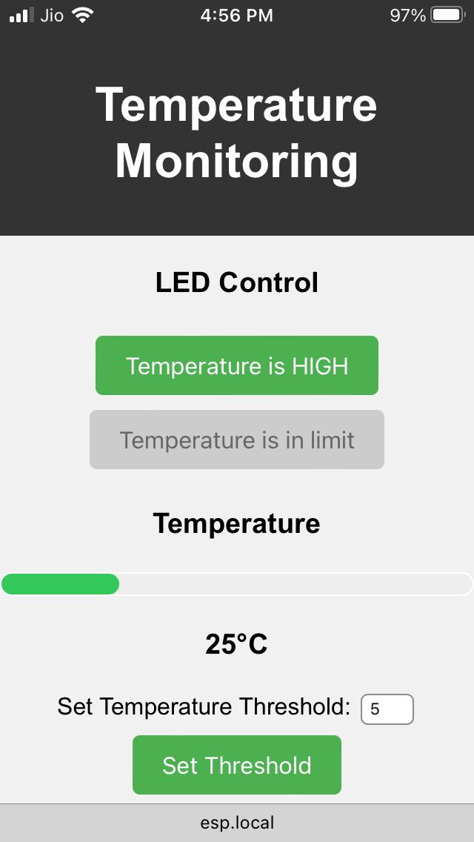

**Fig 2.1 When temperature is not in limit**

**VI. CONCLUSION**

The cold storage monitoring is an useful IOT project for checking the temperature of our closed storage so we can ensure by getting notified when we require to.

**VII. FUTURE SCOPE**

Integerating with automation devices and can connect with an RFID or GSP module to access the temperature remotely. Connecting with an compressor to ensure maintaining the temperature in its constraints

**Fig2.2When the temperature is in limit**